CST8002 Programming Language Research Project

# Hybrid 02 - Time Management and Project Management Software

**See Brightspace for Due Date**

**Refer to the Weekly Schedule document posted in Brightspace under Course Information for additional requirements common to all assessments.**

# Overview

Your research assignments in this course will ask you to apply personal time management for your practical projects. Your discussion board posts, and reflective reports will ask you to reflect on your personal time management and how you could improve based on your personal experience.

# Tasks

Review the learning materials below:

## What is a Work Breakdown Structure?

A Work Breakdown Structure (WBS) decomposes a complex task (project) into smaller tasks. For the purposes of our course consider this to be like breaking down a programming project into smaller parts for planning development. The focus in creating the WBS is the break down of the tasks into smaller units of work, not the time needed for each task. While in some cases a graphical WBS is used, in our course a hierarchically numbered plain-text WBS is required. (It is easier to copy plain-text tasks into the Project Management software you will use in the next step). Please see [1] for an overview and design principles but focus on the section named “coding scheme” for an example of the format expected for our course.

## What is a Gantt Chart?

A Gantt Chart is a Project Management tool that is used to estimate and track time durations of tasks [2]. For our course we will first focus on decomposing each practical project into a sequence of smaller tasks using a WBS for each, then the WBS tasks are entered into Project Management software (Microsoft Project, or Project Libra) where a Gantt Chart is used to estimate the time needed for each task and to mark milestones for project delivery. Please see resource [2] for an overview of Gantt Charts.

## How do I get MS Project or Project Libra Software?

To obtain Microsoft Project for free as part of being enrolled in a Bring Your Own Device (BYOD) program please follow the instructions from Information Technology Services (ITS) on this website:

Algonquin College. (n.d.). Microsoft Windows, Visio, and Project: How do I get it? [online] Available at: <https://www.algonquincollege.com/byod/windows/> [Accessed on 5 Nov 2024]

If you would like to explore an open-source project management software package, or if you are not using a Windows laptop you can download and then install Project Libra from this website:

ProjectLibra. (n.d.). ProjectLibre Community Edition. [online] Available at: <https://www.projectlibre.com/> [Accessed on 5 Nov 2024]

Important: Download and install the desktop version for ProjectLibra, the cloud version is not free.

## WBS: Example of Expected Format for Research Assignments

MS Word has a bullet style that will do the hierarchical numbering, see the image below to use it, and then use the indent buttons in the ribbon to create sub-tasks. Alternatively, manually create the numbers and indent with tab keys. Note: Do not use a table, or a chart / text-bubble style WBS. Your WBS should be easily edited in a text editor like Notepad, if needed.

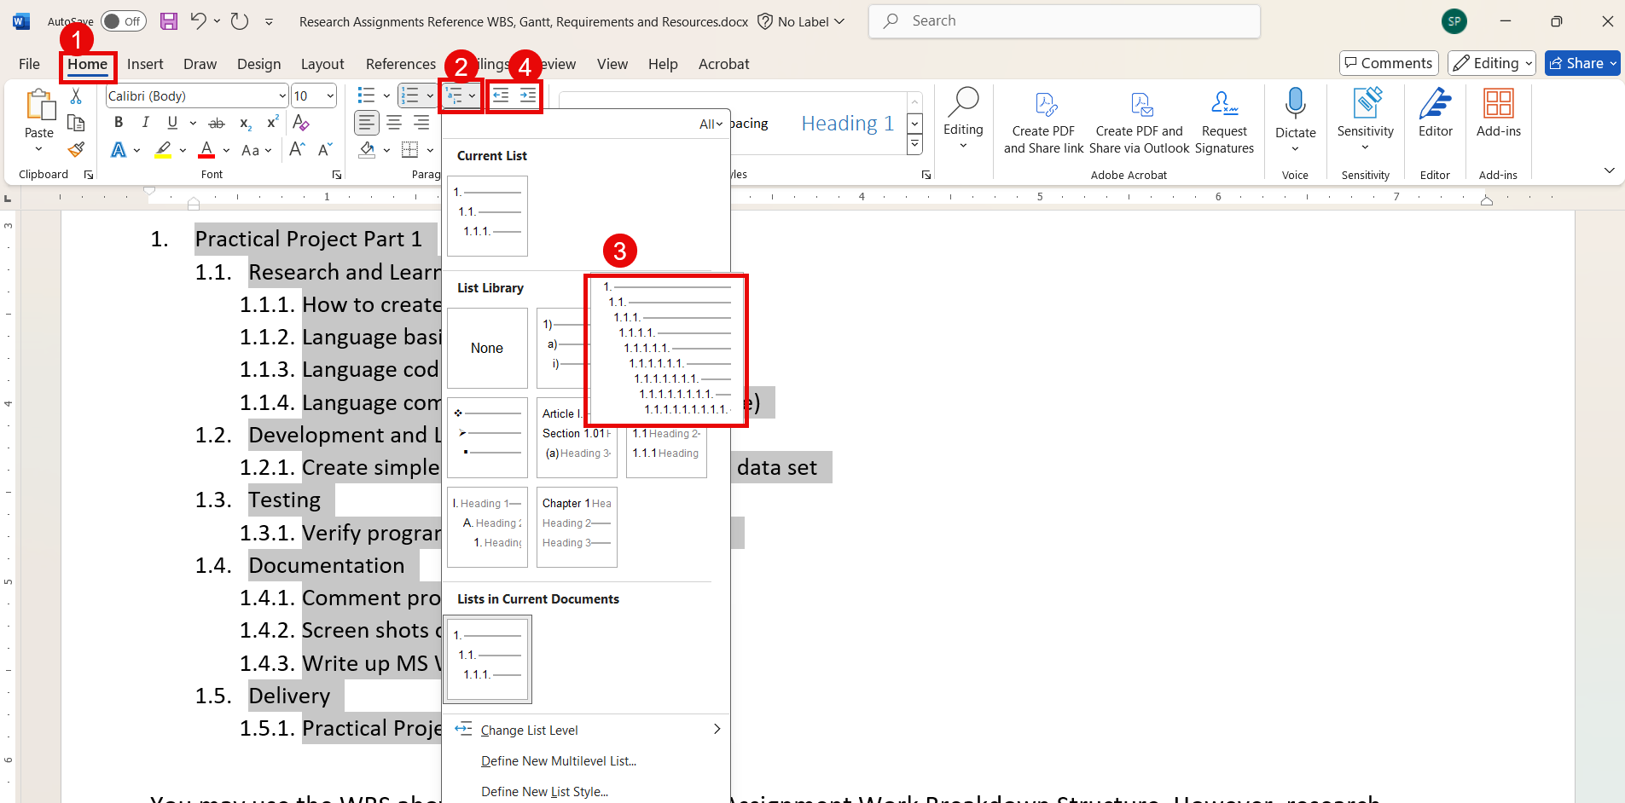

As per the image above, use the (1) Home Tab, then (2) Multilevel List Option or Button, then in the list library the item (3) with 1. and 1.1. etc., finally the increase and decrease indent buttons (4) were used for each line of text. This is an example of a WBS using the bullet style above:

1. Practical Project Part 1
   1. Research and Learning
      1. How to create simple program
      2. Language basics, syntax
      3. Language coding style
      4. Language commenting style (document code)
   2. Development and Learning
      1. Create simple program, based on provided data set
   3. Testing
      1. Verify program output meets expectations
   4. Documentation
      1. Comment program
      2. Screen shots of running program
      3. Write up MS Word document
   5. Delivery
      1. Practical Project Part 1 Submitted
   6. Demonstration
      1. Practical Project Part 1 Lab Demo (Use your lab periods actual date as a reminder)

You may use the WBS above for your first Research Assignment’s Work Breakdown Structure. However, research Assignments 2, 3 and 4 will require you to figure out the needed WBS on your own.

## Gantt: Example of Expected Format for Research Assignments

A screen shot of MS Project with numbers used to indicate the parts corresponding to the text below the image. 1) Task Name Column, 2) Task Mode Column, 3) Duration Column, 4) Add New Column, Column, 5) A milestone task with duration zero, 6) Resource Names Column.


1. The WBS tasks were copy and pasted line by line. I indented sub-tasks using the indent-task button. I dragged and dropped the timeline bars of earlier top-level tasks to their following task to link them which helps using automatic scheduling easier. E.g., the higher-level tasks like Research and Development are in sequence, while the sub-tasks under each run in parallel. (double left-click on a relationship line to edit or remove the relationship).
2. Automatic scheduling was turned on for most of the tasks in the Task Mode Column, you can experiment with manual/automatic scheduling to see the effects on durations and start and end dates. (A push-pin icon is manually scheduled, a bar with arrow is automatically scheduled). See the note below on 5-day vs 7-day work week if using automatic scheduling.
3. Durations that were entered manually have no ‘?’ in the Duration column, durations that were estimated automatically by MS Project have ‘?’ to alert a project manager to verify by manually typing in the value. [3]
4. The “Add New Column” drop down was used to add the WBS column, which was automatically populated with numbers that should match the WBS created earlier.
5. The milestones (diamond symbols for timeline bar) were given a duration of zero and should have the due date for the Practical Project Parts set manually. Durations for earlier parts can be tweaked but the delivery of the Practical Project Parts is fixed by your professor. (Submission of work, and demonstration in the lab period).
6. Replace the “Your Name” with your actual Student Name as seen in ACSIS for at least one task in the resource’s column.

Additional Notes:

MS Project defaults to a 5-day work calendar, so to adapt to the course delivery, which is 7 days a week a 7-day calendar was created and applied. There is a website below [4] in the resources section with steps on how to set to 7-day workweek calendar.

Getting exact dates and times in the Gantt chart is not required in this course, excepting the due date for the delivery milestone, and the project demonstration milestone. Dates for time estimates can be one to two days off from what would be expected in the current semester. Your professor is looking for the items in the Rubric (Grading Section) and not looking for perfect scheduling of tasks.

Your Discussion Forum assessments will ask you to reflect on your time estimates. If your time estimates turn out to be wildly inaccurate, but your Practical Project Parts (1, 2, 3 and/or 4) comes in on time, this is okay. For this course the process of estimating time, researching, learning and applying, documenting, reflecting is more important than good time estimates. You will get better at estimating time as the course progresses.

**You may want to consider adding the discussion board post date to your Gantt chart as well. Discussion boards in Brightspace may not be automatically added to the course calendar so find the date in the Weekly Schedule Document and make a note so that you do not forget your discussion board post(s).**

# Grading (10 Points Total)

* There is a short Hybrid Quiz in Brightspace to test your knowledge based on this handout and the readings (articles [1] and [2] below).
* Hybrid Quiz 02 – 10 questions, 1 point per question.

## Recommended Readings / Resources / Sources Cited

[1] Wikipedia. (n.d.). Work breakdown structure. [online] Available at:

<https://en.wikipedia.org/wiki/Work_breakdown_structure> [Accessed on 5 Nov 2024]

[2] Association for Project Management. (2024). What is a Gantt Chart? [online] Available at:

<https://www.apm.org.uk/resources/find-a-resource/gantt-chart/> [Accessed on 5 Nov 2024]

[3] Dale Howard. (July 31, 2018). About Those Pesky Question Marks in the Duration Column. [online] Available at: <https://www.mpug.com/pesky-question-marks-duration-column/> [Accessed on 5 Nov 2024]

[4] Adrian Neumeyer. (2024). How to set up a 7 day work week in Microsoft Project. [online] Available at: <https://www.tacticalprojectmanager.com/7-day-workweek-ms-project/> [Accessed on 5 Nov 2024]

University of York. (2024, Oct, 16). IEEE referencing Style. Referencing styles – a Practical Guide. [online]. Available at:

<https://subjectguides.york.ac.uk/referencing-style-guides/ieee> [Accessed on 5 Nov 2024]

## Project Management Software: Microsoft Project or ProjectLibre and Learning Resources

If your computer **is** using a Windows Operating System **and** you can get MS Project from the Microsoft Azure Portal (<https://aka.ms/devtoolsforteaching> )

* Get Microsoft Project 2019 (or newer)
* Reference Recommended Book
  + Microsoft Project 2019 Step by Step (May 25 2019) by Cindy Lewis, Carl Chatfield, Timothy Johnson. Microsoft Press; 1st edition, ISBN-10: 1509307427, ISBN-13: 978-1509307425
  + NOTE: This book is available free, digitally, on Safari, via the School Library Website.
* The recommended book is available in Safari Books online in the school library. look for information on task entry, create sub-tasks, link sequential tasks, milestones

OR

If your computer **is not** using a Windows Operating System **or** you are having trouble obtaining MS Project

* Get ProjectLibre Community Edition from <http://www.projectlibre.com/>
* Recommended Learning Resources
  + project-management.com. (September 15, 2016). ProjectLibre Tutorial Part 1: Creating Your First Project. Retrieved from <https://project-management.com/projectlibre-tutorial-part-1/>
  + project-management.com. (May 1, 2015). ProjectLibre Tutorial Part 2: Task breakdown, Resources. Retrieved from https://project-management.com/projectlibre-tutorial-part-2/
* Read all parts of tutorial 1, then read tutorial 2 up to where you learn to add yourself as a resource, (there is no need to continue with project costs calculations.)
* Tip: Do not use a forward scheduled Gantt, our course has a strict due dates with the delivery of each Practical Project Part (1, 2, 3 and 4).

**Note:**

* **ProjectLibra will run on a windows operating system, for example if the license period for your digital resources portal copy of MS Project has expired.**
* **MS Project is the preferred software but you may use either MS Project or ProjectLibra files.**